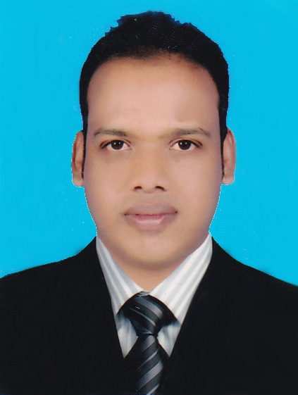
Md. Abbas Uddin
Contact Address:
C/O: Nur Miah House
Moslimabad, North Patenga, Patenga(4204), Chattagram.
Cell Phone: +88-01626-316784
Email: au.masud123@gmail.com

CAREER OBJECTIVES:

Seeking an eligible environment to utilize my skills and abilities in a competitive and dynamic arena being resourceful, innovative and flexible and becoming a successful leader through my aptitude, hard work, honesty dedication and team work ability.

ACADEMIC QUALIFICATION:

Bachelor of Business Administration . (BBA/Hon’s)

University : National University.
Institute : Institute of Business Studies (I.B.S), Chattagram.
Result : 2.62 out of 4.00
Year of passing : 2018
Higher Secondary Certificate (H.S.C.)

Institute : Barrister Sultan Ahmad Chowdhury College
Group : Business Studies
Result : 2.80 out of 5.00
Year of passing : 2012
Board : Chattagram Board.
Secondary School Certificate (S.S.C.)

Institute :Patenga High School
Group : Business Studies
Result : 3.69 out of 5.00
Year of passing : 2010
Board : Chattagram Board.

Computer Skills :

- MS Word,
- MS Excel,
- MS power point,
- E-Mail
- Internet Browsing

Professional Profile:

- Self-confident & being positive.
- Willing to accept responsibility & perform accordingly.
- Strong interpersonal communication skill & Able to work under pressure.
- An effective team player.
- Like to communication people and develop public relation.
- Capable of work in under busy environment.
- Well-mannered, smart, disciplined and punctual.

LANGUAGE PROFICIENCY:

- As a mother tongue I have good command on spoken and written in Bengali.
- As second language I have good command on spoken and written in English.

PERSONAL INFORMATION:

Name : Md. Abbas Uddin
Father’s Name : Md. Amir Ahmed
Mother’s Name : Kawsar Parvin
Permanent Address : C/O : Nur Miah House, Vill: Muslimabad, North Patenga,
P.O : Patenga (4204), P.S : Patenga, Dist: Chittagong.
Present Address : Do.
Date of Birth : 07th December, 1993
Religion : Islam
Marital Status : Married
Nationality : Bangladeshi
Blood Group : O (+)

Employment History:

Year of Experience: Working experience Three years

Admin & Accounts

(November 01, 2017 – November 30, 2020)

LTL Global Engineering (pte) Ltd.
Head Office : Arzed Chamber 13, A/K Kandhaker Road, Mohakali Dhaka.
Department: Accounts.
Year of Experience: Working experience Five month
Trading Officer
(Decembe 01, 2020 – April 30, 2021)

Eminent Securities Ltd
Member of Dhaka Stock Exchange Ltd
Lyli Pond Center , Rk Mission Road, Dhaka.

Reference :

- Md. Emran Hossain
Project Engineer (Civil)
LTL Global Engineering (pte) Ltd..
Head Office : Arzed Chamber 13, Mohakali Dhaka.
Department: Accounts.
Mobile : 01942-194907
E-mail: engr.emran.ltl@gmail.com

- Md. Nure Alam
Medical Technology
Samorita Hospital Ltd.
89/1 Panthapath, Dhaka 1215, Bangladesh.
Mobile : 01711-283770

Certification:
I declare that the information supplied by me on these curriculum vitae is complete, true and correct in every particular. I acknowledge that the authority may terminate the job if I have misrepresented my past or present circumstances and that this termination may take place at any stage during my candidature.

Md. Abbas Uddin

Date :

